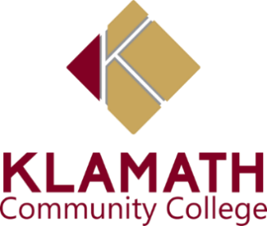

**Weekly ASKCC Meeting**

**November 10, 2022**

**9:30AM**

**Minutes**

1. **Roll Call**

**Present:** Deveyn Horne, Jennifer Stone, Chantal Ramirez, Jaden Pantoja-Roberts, Carissa Catterall, Kassandra Hedrick,Erica Lawson, Oscar

**Absent:**

1. **Agenda & Minutes**

Approval for 11/4 Agenda minutes

Review and Adopt Agenda for October 4, 2022

Motion to Approve Agenda by Chantal

Second by Jennifer

1. **Welcome Week**
2. Devyn asked Jaden if flyers were done for welcome week and town hall.
3. 9-13th , vote on the budget enact week. Deveyn suggested having an educational speaker.
4. Jennifer motioned one for ice skating.
5. Chantal mentioned Karaoke.
6. **Old Business** 
   1. Devyn said we need to go over the pictures for costume contest and to meet on Monday.
7. **First Gen week** 
   1. Deveyn asked if there was anything we could do better .
   2. Oscar gave kudos to the team & a goal for next time how to spread the word out.
8. **Friendsgiving** 
   1. Deveyn stated we need to do another banner for it, get the activities listed.
   2. Devyn asked for flyers to be done two weeks before and put the canvas flyer in earlier
   3. Jaden said he has the banners done for most of the events this week.
9. **Info items** 
   1. Deveyn listed the events for fuels for finals and we decided Monday rockstars & Italian sodas,Tuesday coffee with cops, Wednesday donuts with deans, Thursday bon fire, Friday ice skating.
   2. Oscar got ahold of the fire department
   3. Jennifer got ahold of the bowling and Jaden will do flyers.
10. **Open Discussion**
    1. Jaden said if students miss out on a tour during welcome week, we can offer students supplies and offer tours to them
    2. Chantal mentioned setting up a in to donate extra unused school supplies, Deveyn said that we would need to find an area for donation since we do not have a lot of room
    3. Employee award dinner, students signed up are doing coat checks, it is December 9th.
    4. Come in early for snowflake parade
11. **Adjourn**
12. Meeting was adjourned at 10:30 a.m
13. Next meeting will take place on October 18th 2022 at 9:15